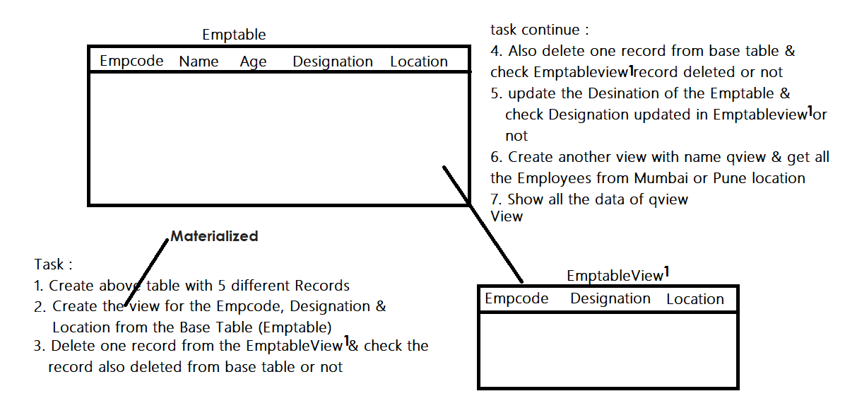

SOLU**TIONS:**

**FOR SIMPLE VIEW**

**Create table emptable( emp­_code integer, name varchar(50), age integer, designation varchar(50), location varchar(50));**

**create view empview as select emp_code, designation, location from emptable ;**

**delete from empview where emp_code = 103;**

**select * from emptable;**

**delete from emptable where emp_code = 102;**

**select * from empview;**

**update emptable set designation = 'Developer' where emp_code = 101;**

**select * from empview;**

**create view qview as select * from employees where location='Pune' or location=’Mumbai’;**

**select * from qview;**

**FOR MATERIALIZED VIEW**

**create materialized view empview as select emp_code, designation, location from emptable ;**

**delete from empview where emp_code = 103;**

**select * from emptable;**

**delete from emptable where emp_code = 102;**

**select * from empview;**

**update emptable set designation = 'Developer' where emp_code = 101;**

**select * from empview;**

**create materialized view qview as select * from employees where location='Pune' or location=’Mumbai’;**

**select * from qview;**